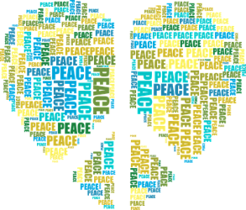
Global Healing Response for Ukraine/Russia Invasion
Intention
My intention for this labyrinth walk is to feel the coherent energy of my own heart, then send that coherent energy toto world leaders and those in the conflict in Russia and the Ukraine.
Meditation
(something you can read to yourself, prior to saying and walking with your intention).
I fully release and let go of those things I cannot change. I let go of my fear of my own challenging world and that of the outside world.
I breathe into my heart; I exhale from my heart.
Let me begin my labyrinth walk with untying my own knots of chaos.
I breath into my heart; I exhale from my heart.
I begin to feel the heart center opening.
Turmoil and conflict undo the world beyond my world. When I take a breath into my heart center, I steady my own energy, my own world.
When I breath into my heart I feed my spirit with the sustainer of life, the breath.
When I exhale from the heart, I am able to direct the gift of heart energy to anyone, anywhere.
I know this to be true.
I am grateful for this practice as I know I am full of generous potential, and capable of sharing it with others.
I open my heart wide proclaiming myself as a resource for humanity.
I begin walking my labyrinth, centered, unburdened, and connected to all.
We connect as One, when we share our heart’s coherent energy.

